Huỳnh Trọng Trí 20146209

Bài 1

l1=50;l2=30;l3=40;l4=20;l5=20;

clc

syms t1 t2 t3 pi

for t4=0:0.5:2\*pi

for t5=0:0.5:pi

for t6=0:0.5:pi

Px= l3 + l4 + l5\*sin(t5)\*sin(t6);

Py=- l2 - l5\*(cos(t6)\*sin(t4) + cos(t4)\*cos(t5)\*sin(t6));

Pz= l1 + l5\*(cos(t4)\*cos(t6) - cos(t5)\*sin(t4)\*sin(t6));

plot3(Px,Py,Pz,"\*");

hold on

end

end

end

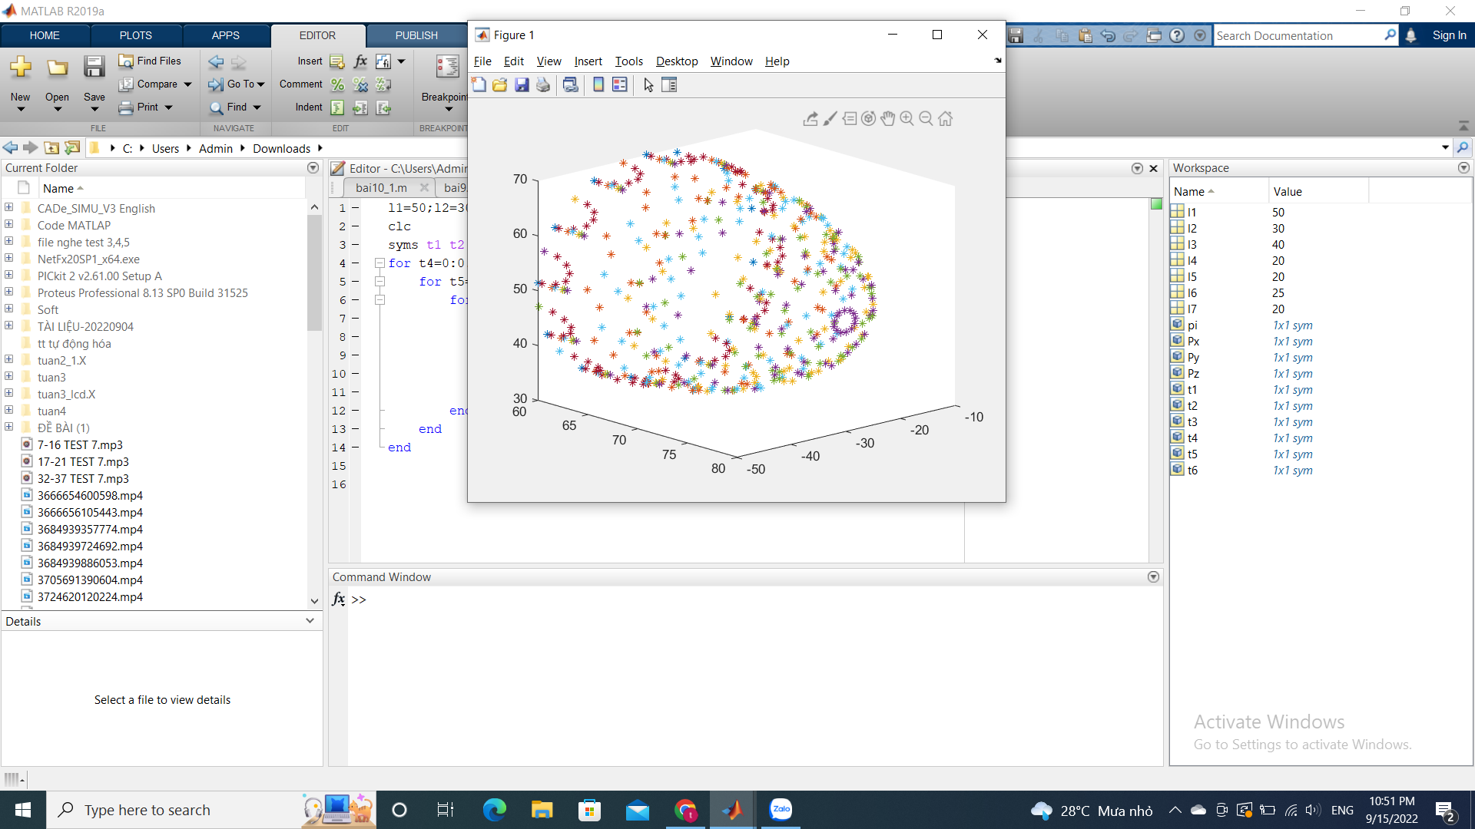

Bài 2

l1=50;l2=60;l3=20;l4=60;l5=40;

clc

syms t1 t2 pi

for t1=0:0.5:2\*pi

for t2=0:0.5:pi

Px=l4\*cos(t1 + t2) + l2\*cos(t1);

Py=l4\*sin(t1 + t2) + l2\*sin(t1);

Pz= l1 + l3 - l5;

plot3(Px,Py,Pz,"\*");

hold on

end

end

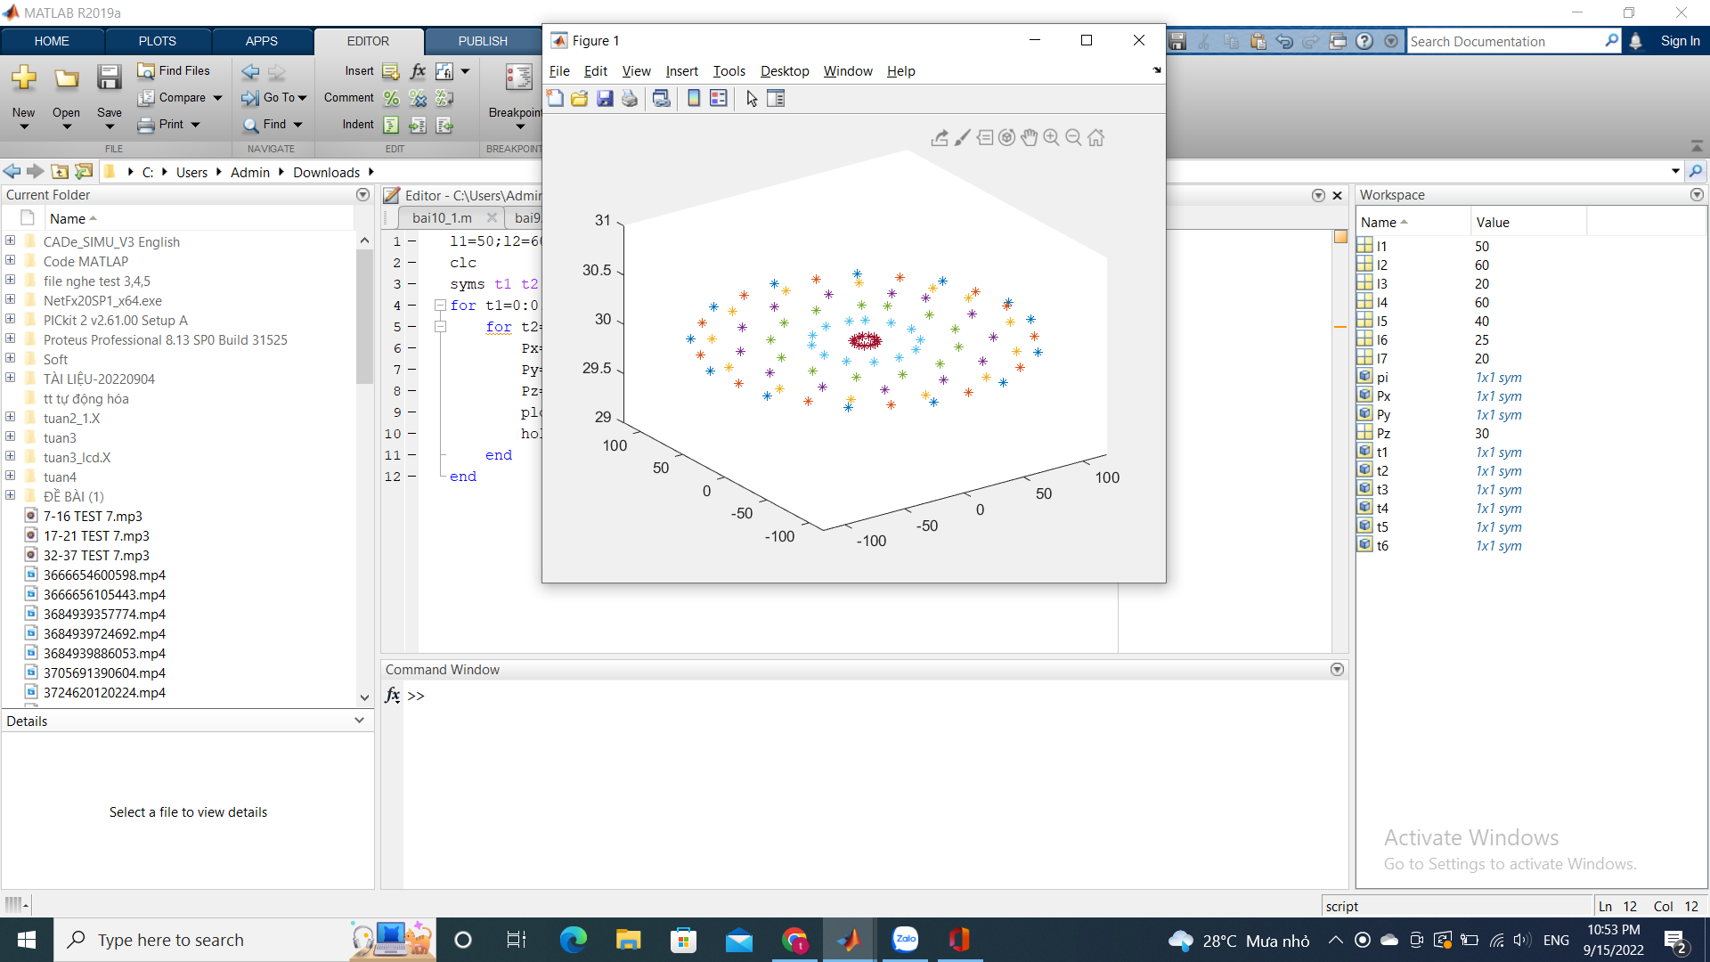

Bài 4

l1=45;l2=30;l3=10;l4=30;l5=30;l6=25;l7=25;

clc

syms t1 t2 t3 t4 pi

for t1=0:0.5:2\*pi

for t2=0:0.5:pi

for t3=0:0.5:2\*pi

Px=cos(t1)\*sin(t2)\*(l4 + l5);

Py=sin(t1)\*sin(t2)\*(l4 + l5);

Pz= l1 + l2 + l3 + l4\*cos(t2) + l5\*cos(t2);

plot3(Px,Py,Pz,"\*");

hold on

end

end

end

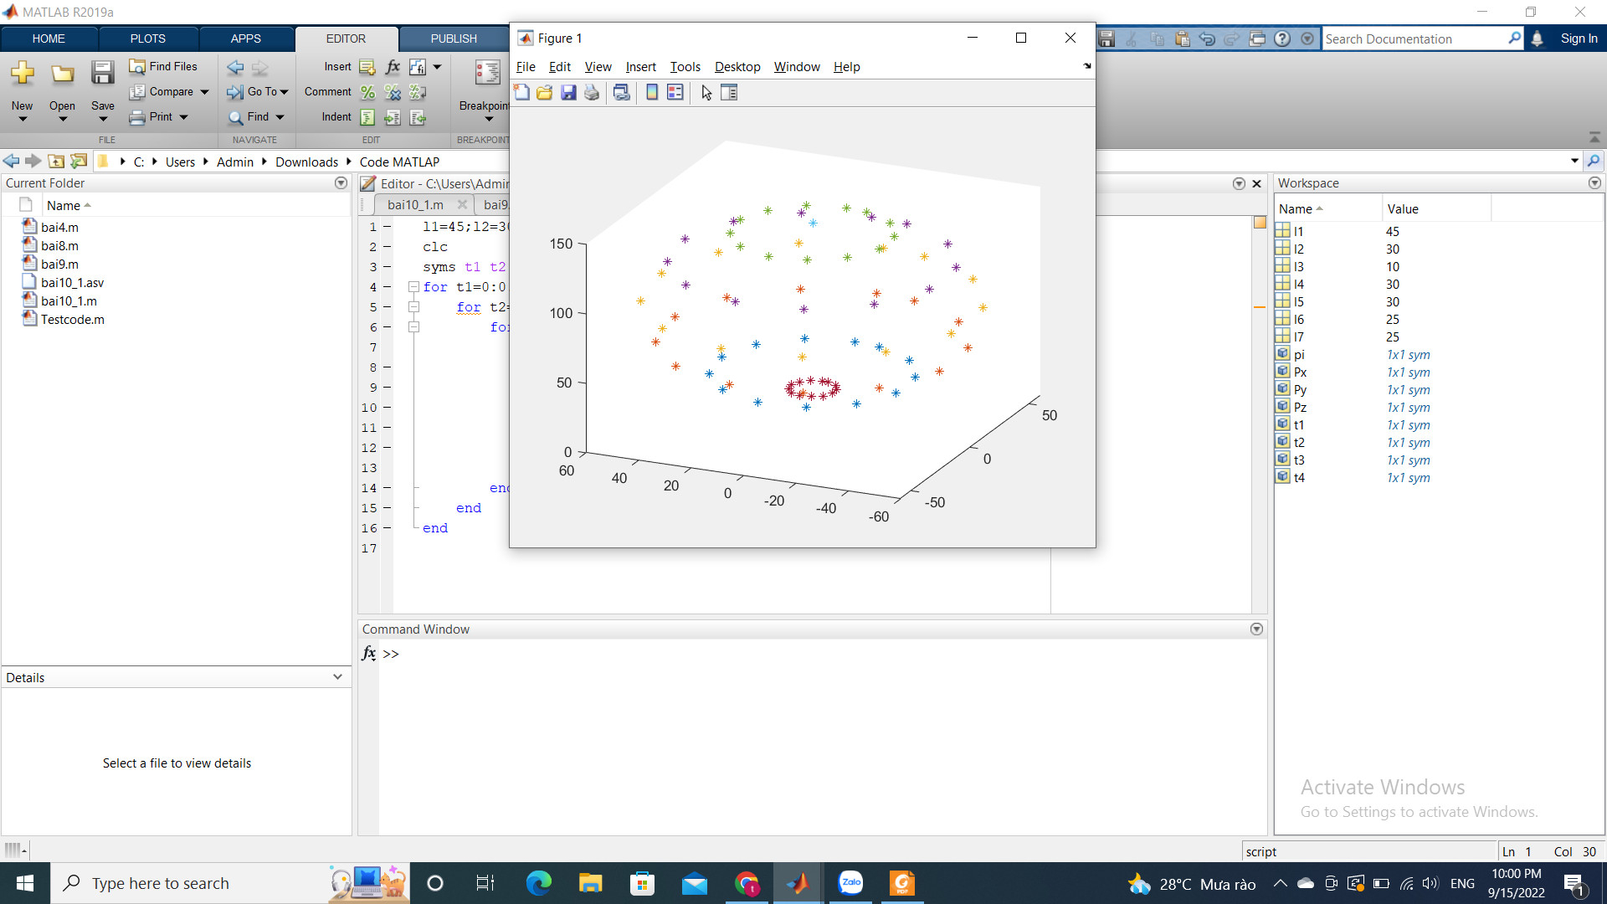

Bài 5

l1=40;l2=40;

clc

syms t1 t2 t3 pi

for t1=0:0.1:pi/4

for t2=0:0.1:pi/2

for t3=0:0.1:pi/4

Px= -cos(t2)\*sin(t1)\*(l1 + l2);

Py= sin(t2)\*(l1 + l2);

Pz= -cos(t1)\*cos(t2)\*(l1 + l2);

plot3(Px,Py,Pz,"\*");

hold on

end

end

end

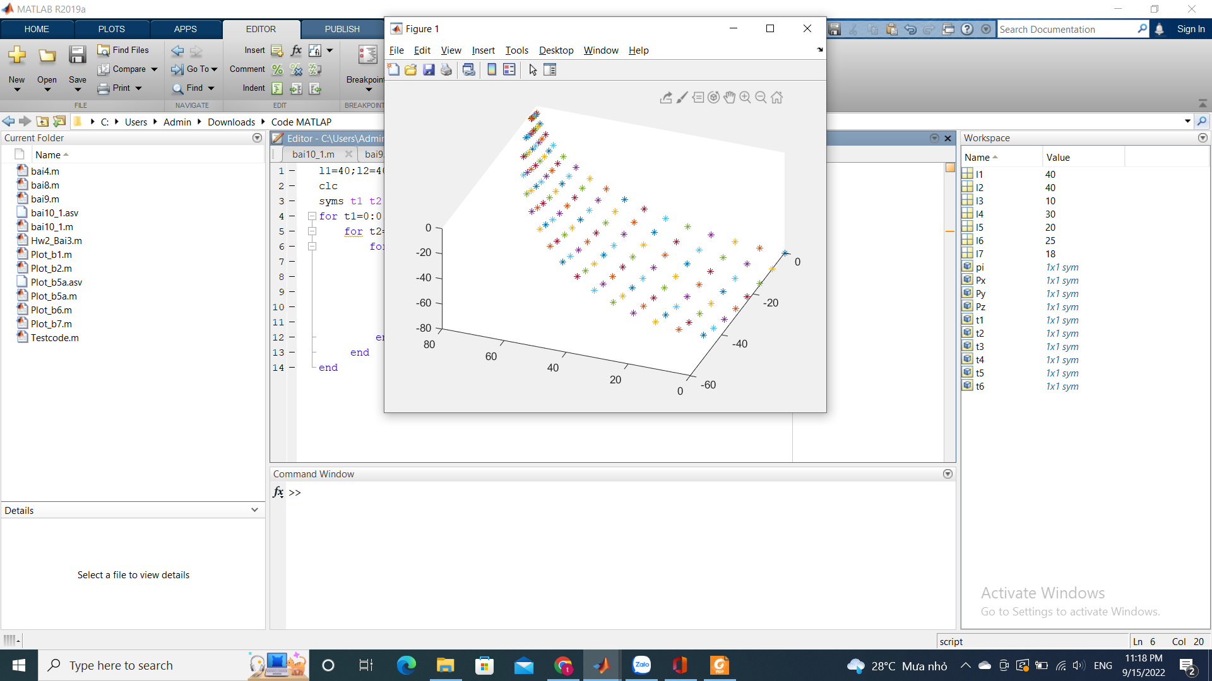

Bài 6

l1=40;l2=15;l3=10;l4=30;l5=20;l6=25;l7=18;

clc

syms t1 t2 t3 t4 pi

for t1=0:0.5:pi

for t2=0:0.5:pi/2

for t3=0:0.5:pi/2

for t4=0:0.5:pi

Px= sin(t1)\*(l1 + l5\*sin(t2+t3) + l4\*sin(t2) + l6\*cos(t2+t3+t4));

Py= -cos(t1)\*(l2 + l5\*sin(t2 + t3) + l4\*sin(t2) + l6\*cos(t2 + t3 + t4));

Pz= l1 + l3 + l5\*cos(t2 + t3) + l4\*cos(t2) - l6\*sin(t2 + t3 + t4);

plot3(Px,Py,Pz,"\*");

hold on

end

end

end

end

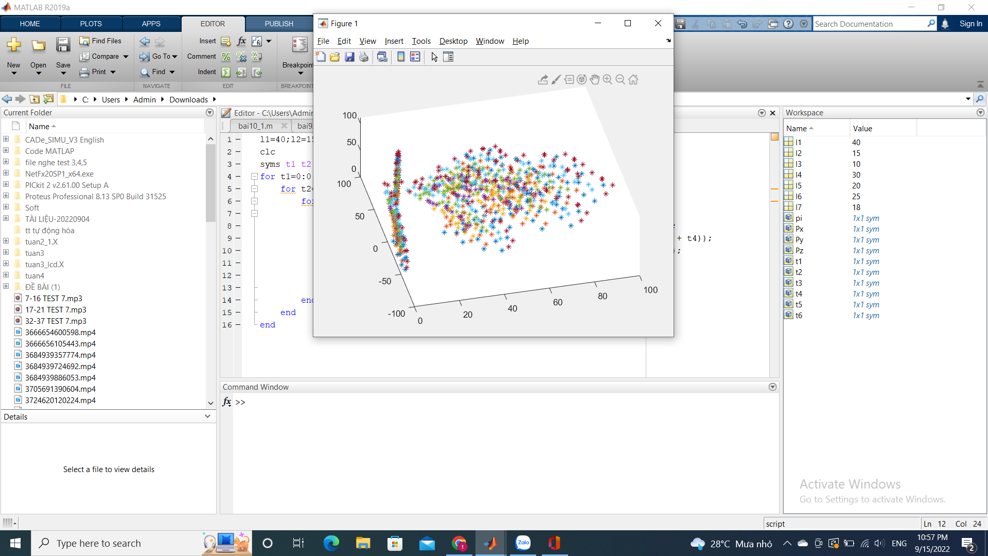

Bài 7

l1=40;l2=15;l3=10;l4=30;l5=20;l6=25;l7=18;

clc

syms t1 t2 t3 pi

for t1=0:0.5:2\*pi

for t2=0:0.5:pi

for t3=0:0.5:2\*pi

Px= -l5\*sin(t1+t2) - l4\*sin(t1);

Py= l5\*cos(t1+t2) + l4\*cos(t1);

Pz= l1 + l2 + l3 - l6 - l7;

plot3(Px,Py,Pz,"\*");

hold on

end

end

end

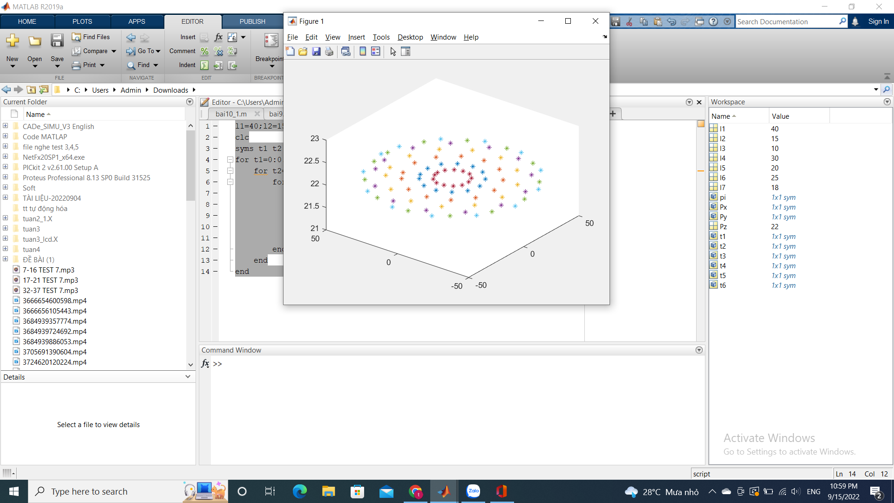

Bài 8

l1=15;l2=20;l3=30;l4=45;l5=12;l6=25;l7=25;

clc

syms t1 t2 t3 t4 pi

for t1=0:0.5:2\*pi

for t2=0:0.5:pi

for t3=0:0.5:2\*pi

for t4=0:0.5:pi

Px=sin(t1)\*(l4\*sin(t2 + t3) + l3\*sin(t2) + l5\*sin(t2 + t3 + t4) + l6\*sin(t2 + t3 + t4));

Py=-cos(t1)\*(l4\*sin(t2 + t3) + l3\*sin(t2) + l5\*sin(t2 + t3 + t4) + l6\*sin(t2 + t3 + t4));

Pz= l1 + l2 + l4\*cos(t2 + t3) + l3\*cos(t2) + l5\*cos(t2 + t3 + t4) + l6\*cos(t2 + t3 + t4);

plot3(Px,Py,Pz,"\*");

hold on

end

end

end

end

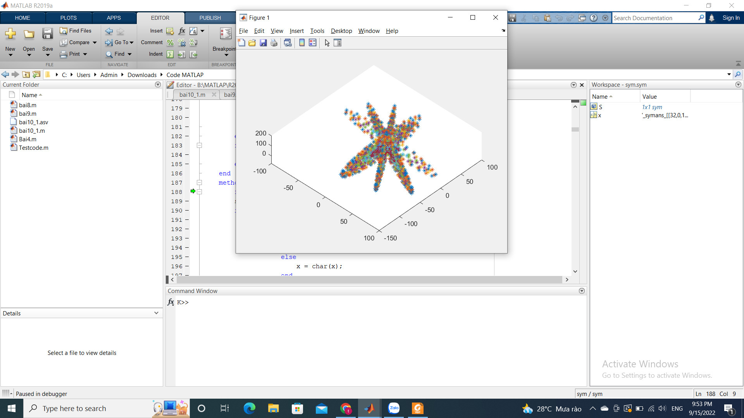

Bài 9

l1=50;l2=15;l3=5;l4=30;l5=25;l6=25;l7=20;

clc

syms t1 t2 t3 pi

for t1=0:0.5:2\*pi

for t2=0:0.5:pi

for t3=0:0.5:2\*pi

Px=- l5\*sin(t1 + t2) - l4\*sin(t1);

Py=l5\*cos(t1 + t2) + l4\*cos(t1);

Pz= l1 + l2 + l3 - l6 - l7;

plot3(Px,Py,Pz,"\*");

hold on

end

end

end

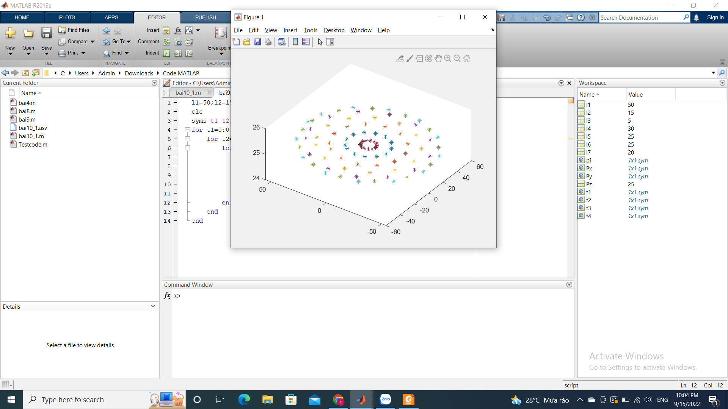

Bài 10 l1=50;l2=15;l3=40;l4=30;l5=10;l6=15;

clc

syms t1 t2 t3 t4 pi

for t1=0:0.8:2\*pi

for t2=0:0.8:pi

for t3=0:0.8:pi

for t4=0:0.8:2\*pi

Px=-sin(t1)\*(l4\*cos(t2 + t3) + l3\*cos(t2) + l5\*cos(t2 + t3 + t4) - l6\*sin(t2 + t3 + t4));

Py=cos(t1)\*(l4\*cos(t2 + t3) + l3\*cos(t2) + l5\*cos(t2 + t3 + t4) - l6\*sin(t2 + t3 + t4));

Pz=l1 + l2 + l4\*sin(t2 + t3) + l3\*sin(t2) + l6\*cos(t2 + t3 + t4) + l5\*sin(t2 + t3 + t4);

plot3(Px,Py,Pz,"\*");

hold on

end

end

end

end

